**Hospital Management System**

**Project Group 8**

Abdul Azeem Syed         - NUID 002853441

Aditi Mahendra Joshi      - NUID 002673547

Aniket Vinayak Patole     - NUID 002290466

Jace Shuler              - NUID 002685644

Rajeev Ramesh       - NUID 002810233

Hospitals, intricate organizations committed to delivering optimal care, grapple with the challenges of disorganized data. Comparable to a malfunctioning tool, unstructured data leads to delays, missed details, and potential patient risks. Inefficient data management hampers care processes, complicates diagnostics, and compromises patient safety. A more streamlined system is imperative for handling all aspects of patient information, encompassing basic details to intricate medical records and room operations. The Hospital Management System strives to leverage data for improved efficiency and communication, placing patient well-being at the forefront. The ultimate vision is to cultivate an environment where robust data analytics contribute to an effective, efficient, and patient-centred healthcare experience.

**ERD**:

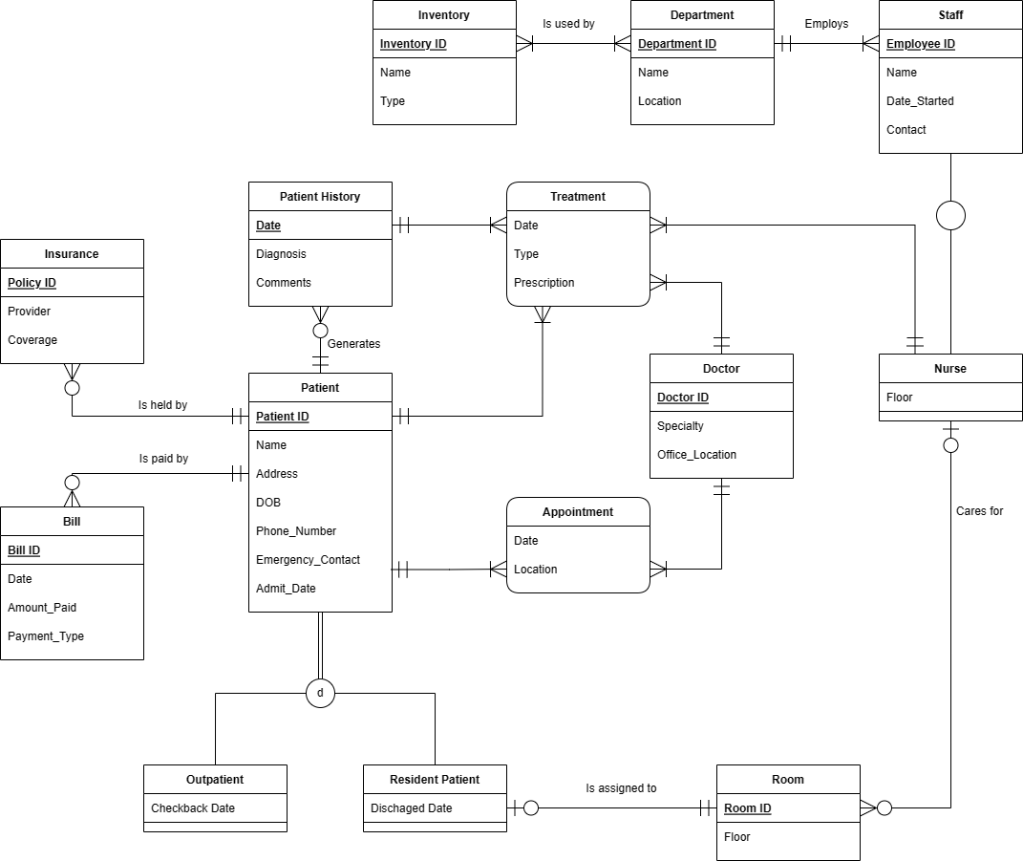

|  |  |  |  |
| --- | --- | --- | --- |
| S.No | Entity | Why is this entity included | Relations to the entity |
| 1. | Patient History | * This entity holds the information of the patient's past and present medical experiences. | * Patient history contains the record of the treatments done. * A patient history is associated with a patient. |
| 2. | Insurance | * This holds the information about the insurance policy the patient has. | * A Patient can hold zero or many insurance policy. |
| 3. | Bill | * This entity stores the information about the bill to be paid by a patient. | * A Patient can pay zero or multiple bills, but each bill is paid only by one patient |
| 4. | Patient | * Maintains the information regarding a patient | * Patient can have one or  many appointments * Patient can have one or many treatments based on the diagnosis. * Patient has disjoint entities that contain different attributes that cannot be placed in the same entity. |
| 5. | Treatment | * Holds the details about the treatment prescribed to the patient. | * Treatment is administered by only one nurse to the patient. * Treatment is administered to the patient by only one doctor. |
| 6. | Doctor | * Holds the record of all the doctors in the hospital | * A doctor can administer multiple treatments to multiple patients. * A doctor has one or many appointments in a day. |
| 7. | Outpatient | * Contains the record for patients who are called for an appointment after a few days |  |
| 8. | Resident Patient | * Contains record of when the patient is going to be discharged | * Resident Patient can have only one room assigned to him. |
| 9. | Room | * Holds the record of room_id and the floor it is located in. | * Room can be a assigned to zero or one Patient. |
| 10. | Staff | * Contains the employees that work in the hospital and the general information like name, start_date etc. | * Staff is employed by only one department. * Staff contains a subclass entity called nurse. |
| 11. | Nurse | * Holds record of the rooms she would be assigned to. | * Nurse contains a superclass entity called staff that is employed by the department. * Nurse cares for 0 to many rooms. |
| 13. | Department | * Holds records of the number of departments present in the hospital and also the location. | * Department employees 1 to many staffs. * Department uses 1 to many inventory |
| 14. | Inventory | * Holds the records of the inventory stock contained in the hospital | * Inventory is used by 1 or more departments. |